32.24: Recall that 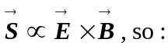
a) 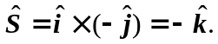
b) 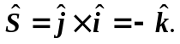
c) 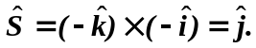
d) 